Renowned Independent Music Tech Publisher Bjooks Announces THE MINIMOOG BOOK, Coming Soon to Kickstarter


Years in the making, THE MINIMOOG BOOK illustrates more than five decades of electronic music history through the lens of the synthesizer that changed everything.

Copenhagen, Denmark, April 10, 2024 — Kim Bjørn, founder of Danish independent book publisher Bjooks, has officially revealed that their latest project, THE MINIMOOG BOOK, will be launched later this month on Kickstarter.

“THE MINIMOOG BOOK is our most vital project yet, documenting and delving deep into the iconic electronic instrument that has shaped generations of musicians and songs.” Bjørn shared. “We’re deeply privileged to bring this beautiful book to Kickstarter for our loyal readers and enthusiasts everywhere. Your support in making this labor of love a reality will mean the world to our small team.”

An undeniable must-have for any electronic music fan, this comprehensive work chronicles the Minimoog’s entire journey — from its prototypes and the very first Model D #1001 through the Minimoog Voyager models and into the present day.

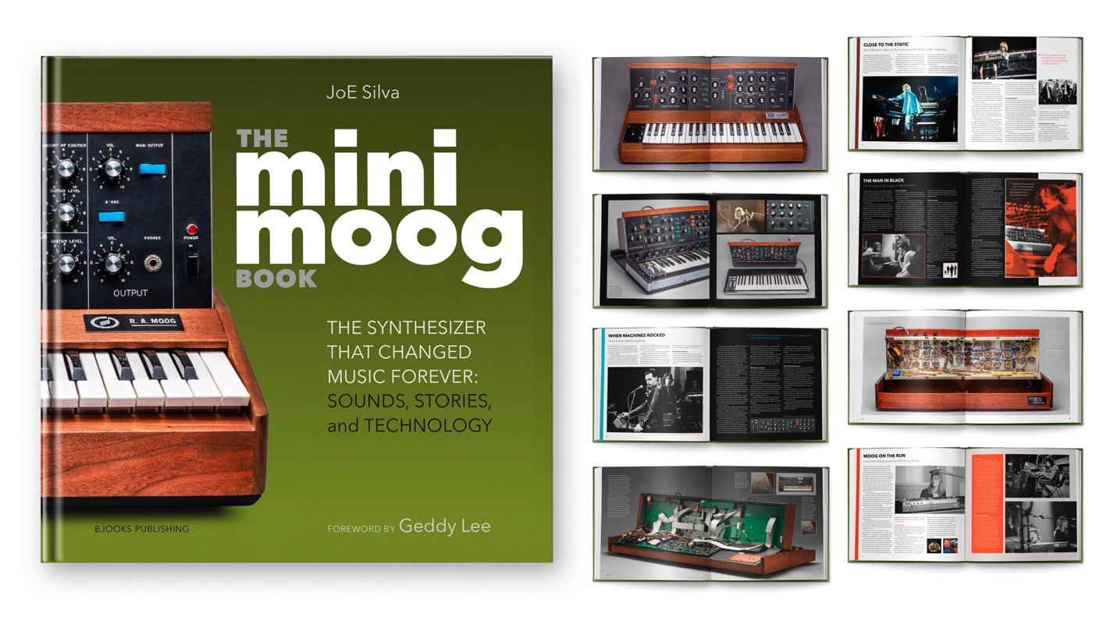

Opening with a foreword from prolific Rush frontman Geddy Lee, THE MINIMOOG BOOK presents more than a decade’s worth of research-turned-storytelling by author, esteemed journalist, and music historian JoE Silva.

"When I started digging into the history of the Minimoog back in 2010,” Silva noted, “I quickly realized how universal it was. I was continuously stumbling upon artist after artist or another famous piece of music that used it. It was pretty clear right away how important the instrument became once it came out…”

Readers can expect exclusive interviews and features with legendary musicians like Keith Emerson, Rick Wakeman, Chick Corea, Tony Visconti (David Bowie), George Duke, Anne Dudley (Art of Noise), Bernie Worrell, Devo, Kraftwerk, Air, J Dilla, Gary Numan, and many others — as well as some of today’s most respected songwriters and multi-instrumentalists, such as Greg Kurstin (Adele), Yumiko Ohno (Buffalo Daughter), Mac DeMarco, and more.

THE MINIMOOG BOOK features exquisite and detailed photography — much of it brand new — as well as schematics, historical promotional materials, engineering interviews, illustrated sound patches, and over 70 artist features. It is the perfect coffee table book and keepsake for lovers of synthesizers, music history, illustration, photography, and timeless books of all kinds.

To be notified when the book is officially available, visit the Bjooks website.

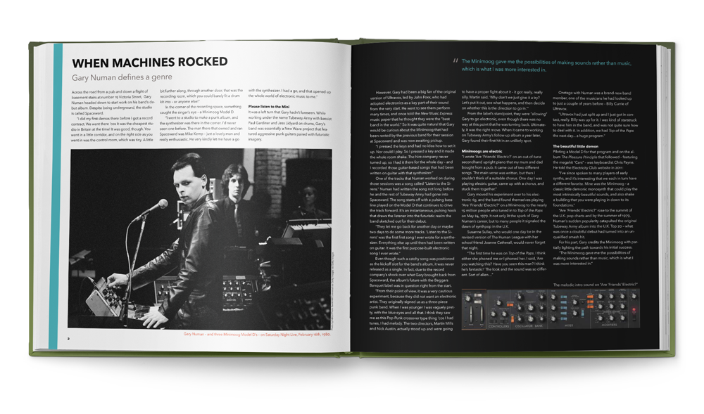
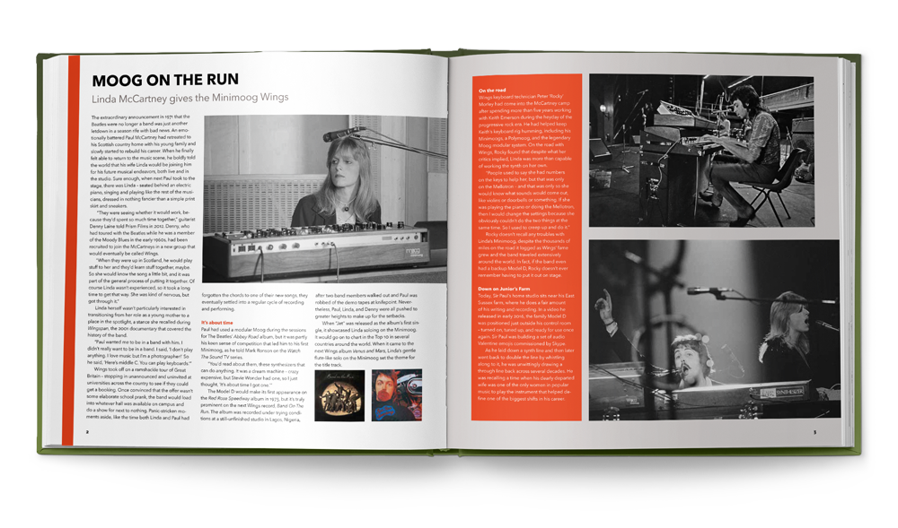



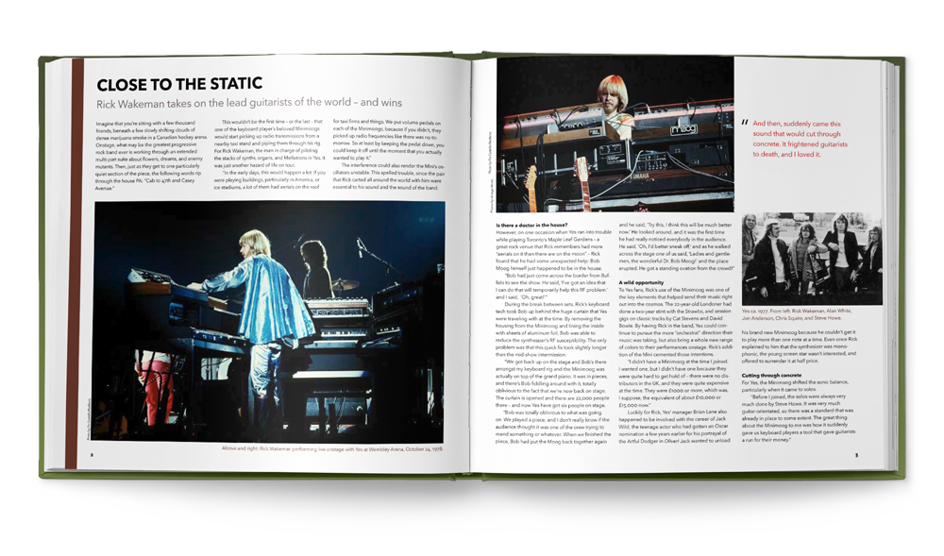


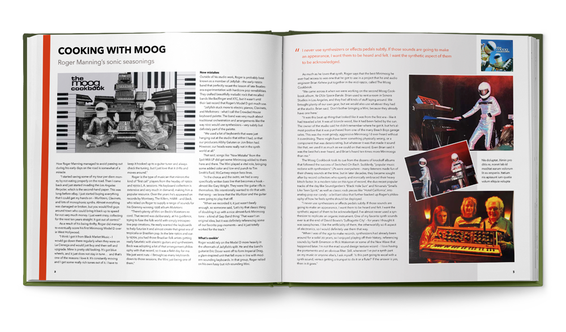
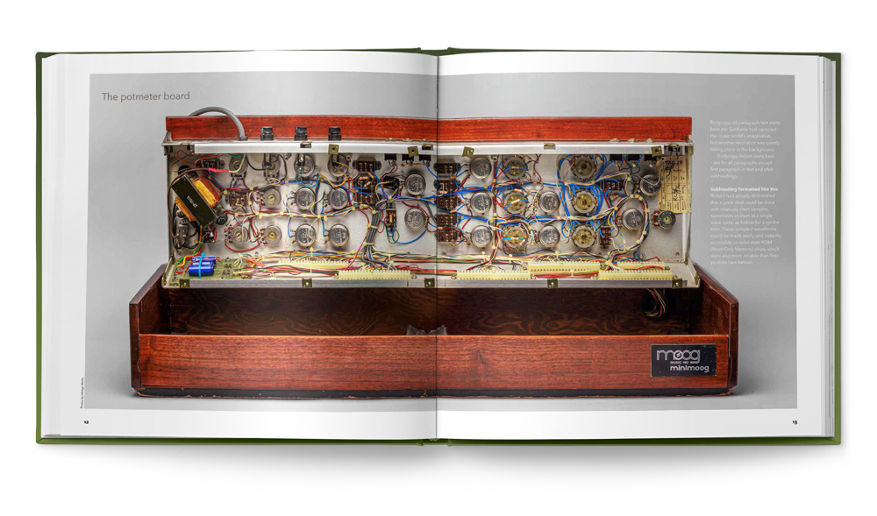
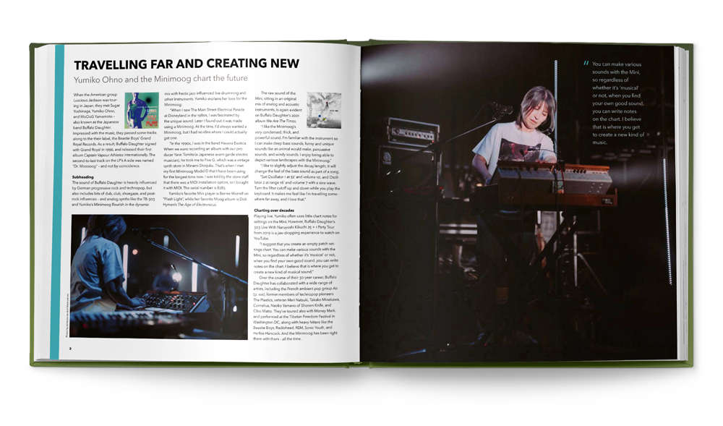

Bjørn’s mission with Bjooks is to create exciting, informative, and beautiful books about music technology, artists, and makers. With existing titles that intimately focus on musical instrument giants like Moog, Roland, and Korg, the publisher is thrilled to bring new inspiration to long-time Bjooks fans and newcomers with this release.

THE MINIMOOG BOOK will be available for pre-order on Kickstarter later in April. Early supporters will get access to special perks and insider info like never-before-seen photos, behind-the-scenes content, a special edition of the book, and more.

For more information on backing the book and securing your early copy, click here.

About Bjooks
Bjooks is a boutique music tech publishing company started by author, designer, and musician Kim Bjørn. His first book, PUSH TURN MOVE, was published in 2017. This was followed by PATCH & TWEAK in 2018, which has since been referred to as the “Bible of Modular Synthesis.” Subsequent titles include PEDAL CRUSH (released in 2019), PATCH & TWEAK with Moog (2020), SYNTH GEMS 1 (2021), and PATCH & TWEAK with KORG (2022). Bjooks’ latest title is INSPIRE THE MUSIC, released in cooperation with Roland Corp. on its 50th anniversary in 2022. Learn more at bjooks.com.

